**User’s Manual**

**Admin's Login Form**

The user must log in his or her username to have access in the system. If the user entered wrong password within three attempts, his or her account will be locked and the system will automatically be terminated. Only the admin is exempted on being locked out from his or her account.

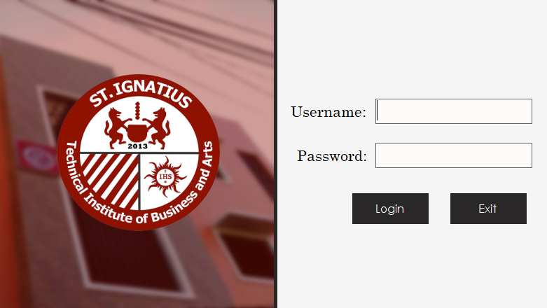

*Login Button*

*Username and Password*

*Text Field*

*v*

**Unlocked Account form**

Only admin can change your status to unlock your account due to put three times wrong password or wrong employees.

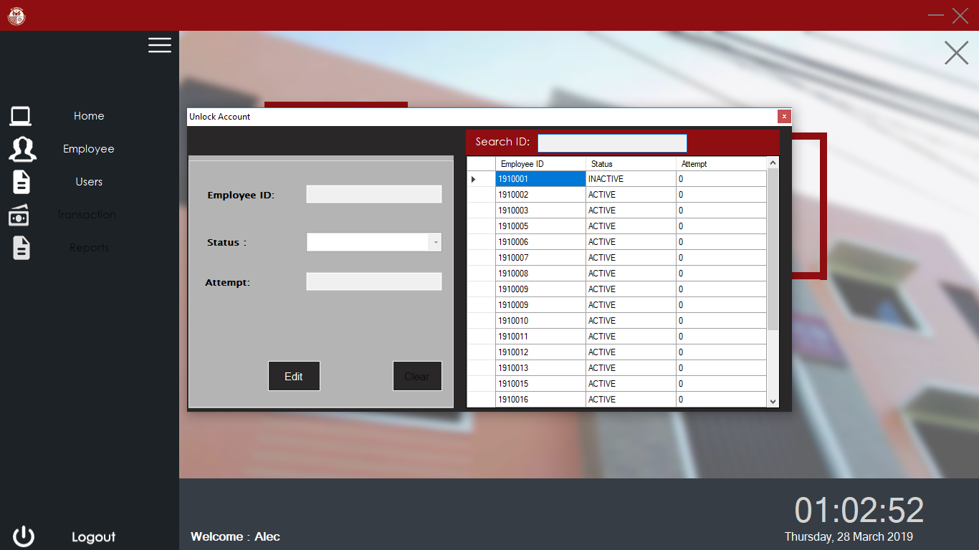

**Admin Main Panel**

It is the main module of the system that has full access on the system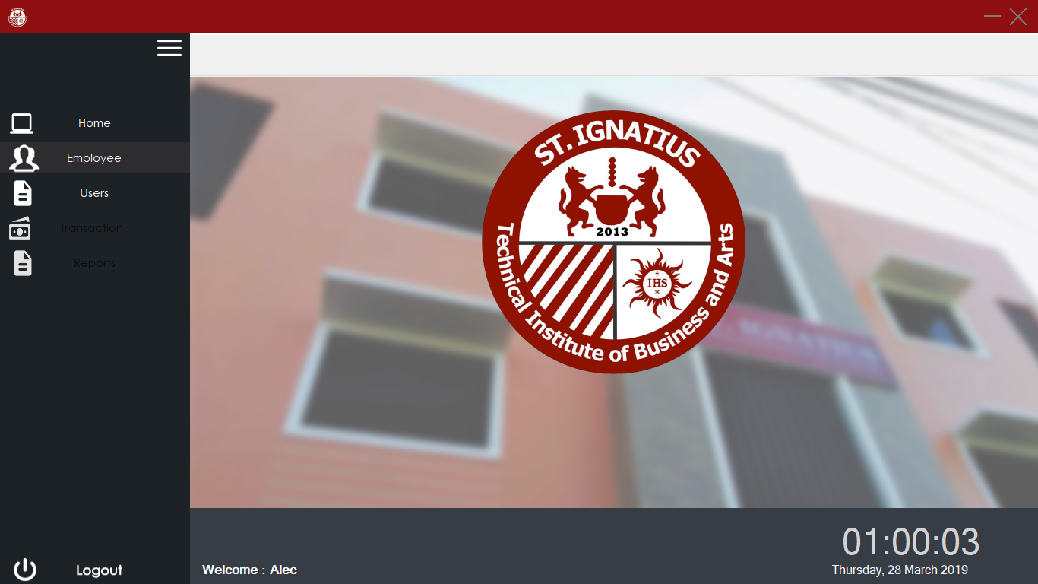. It shows the navigation button in left side and other function of the system.

*Navigation Bar*

**Employee Panel**

Once you click the Employee button will show a three category “Register”, “Summary of loads”, “Attendance Data”.

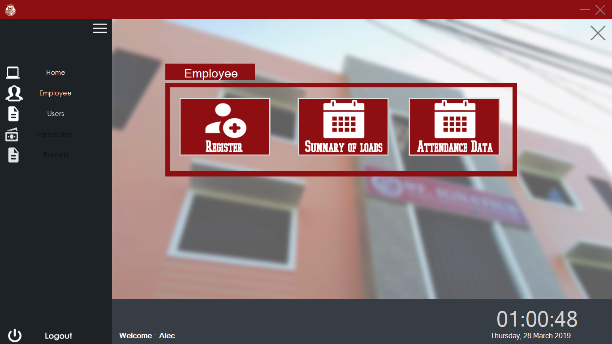

View Attendance Data

*Add Employee Summary of Load*

*Registration Employee*

**Employee Registration Form**

The admin can add a new faculty or Admin with auto generation of Employee ID and password from the information they provided in the "first name", "last name" and "date of birth" etc. You can choose your own desire rest day and Also, the admin has the privilege to manage its system users. And you can search an Employee using search bar.

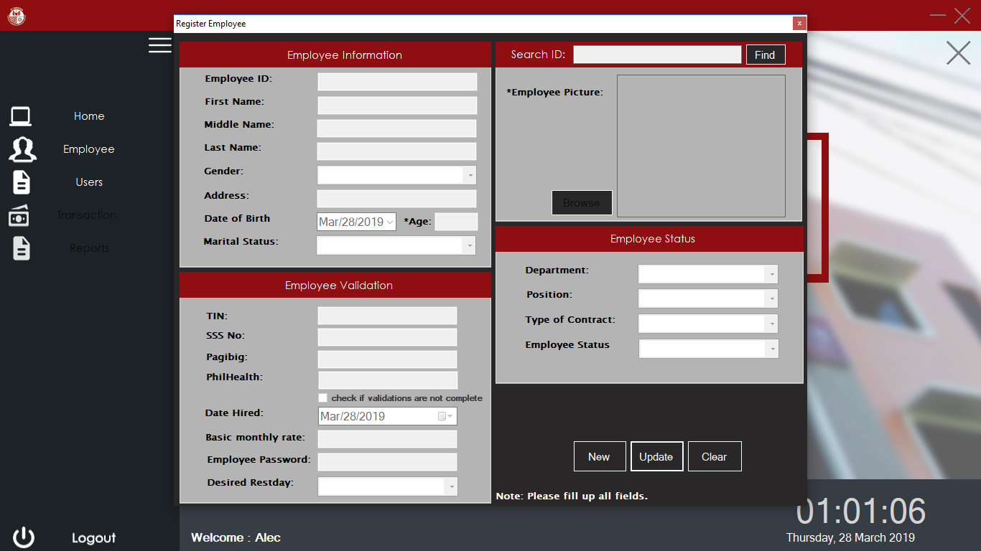

*Search Bar*

*Adding Employee Picture*

*New user's Personal info and automatic generate Employee ID and password.*

*Employee Status*

*New, Update and Clear Button*

**Adding Summary of load for employee Form**

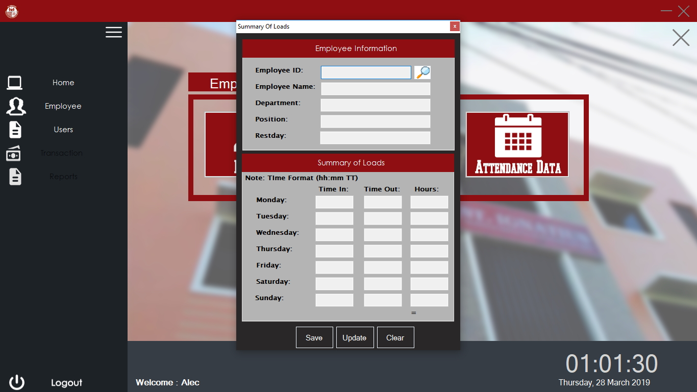In this panel it will show an employee information using search bar. Admin can manually input your summary of loads schedule.

*Save, Update and Clear Button*

*Manual Input of Summary of Loads*

*Personal Employee Information*

*Search Bar*

**Attendance Data Form**

In this form you can see your attendance time in and time out and can see a working time that you work, it can also a late, undertime and deduction. Admin can adjust your adjustment type if you want to leave or official business. Admin can send all data to finance in cut off only.

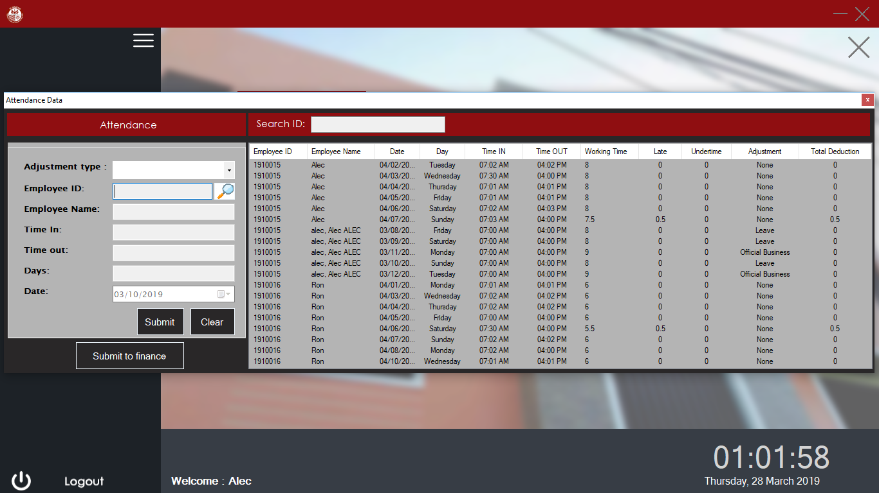

*Search Bar*

*Adjustment of Employee*

*Submit and Clear Button*

*Attendance time in and time out of employee*

*Submit button to finance*

**Transaction Form**

If you click transaction button at the left side it will show a two category “Payroll” and “Loan”.

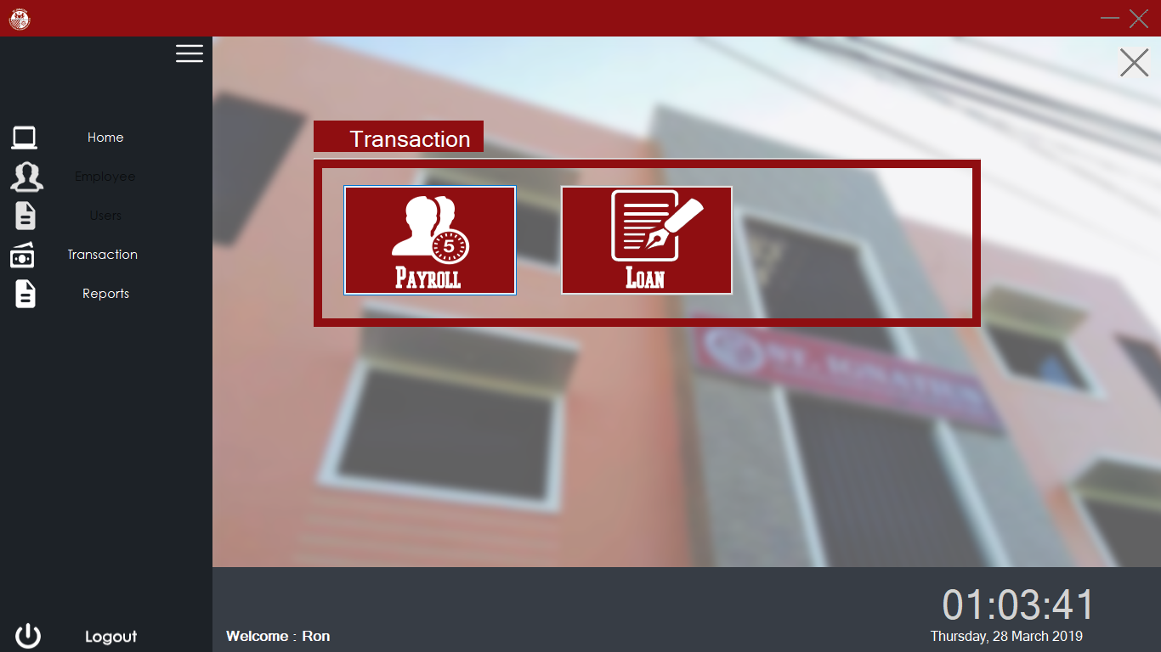

*Payroll*

*Loan*

**Generate Payroll Form**

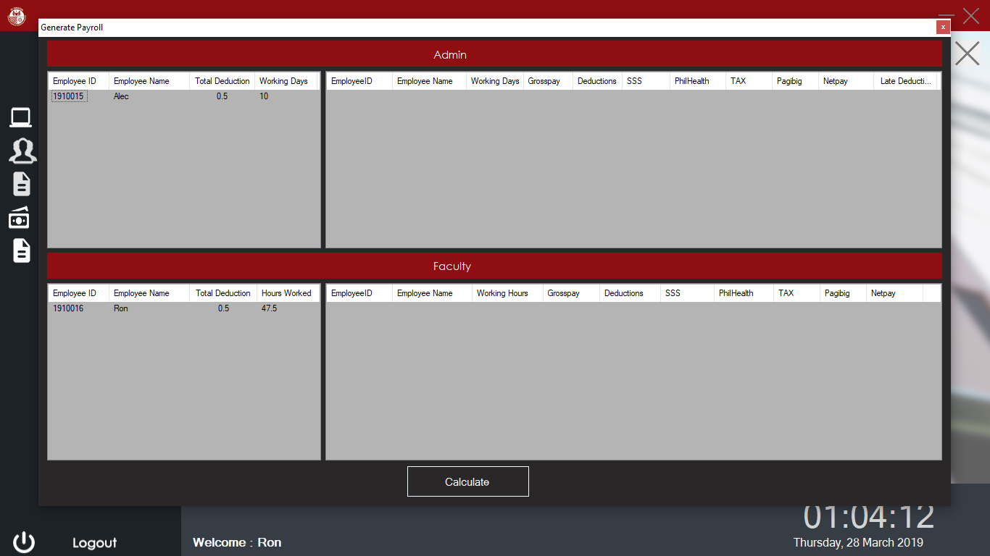This form it uses for generating all attendance that attend to your work.

*Generate all attendance data*

**Reports Form**

If you click the report button it will show a four category they are “Payroll Report Faculty”, “Payroll Report Admin”,” Pay slip Admin”,” Pay slip Faculty”. It uses for generating all reports.

*Reports that generate all attendance base on your position*

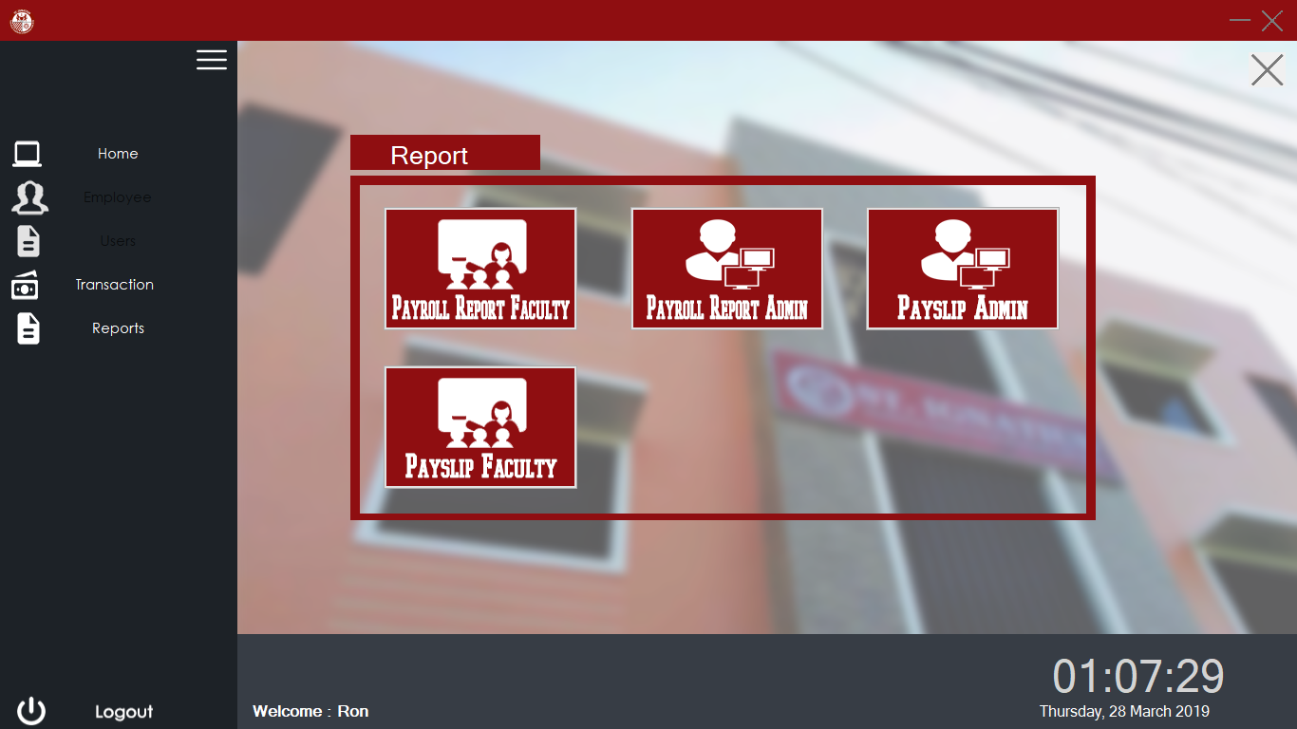

**Payroll Faculty form**

This form shows your preview of summary and ready to print payroll summary reports of faculty.

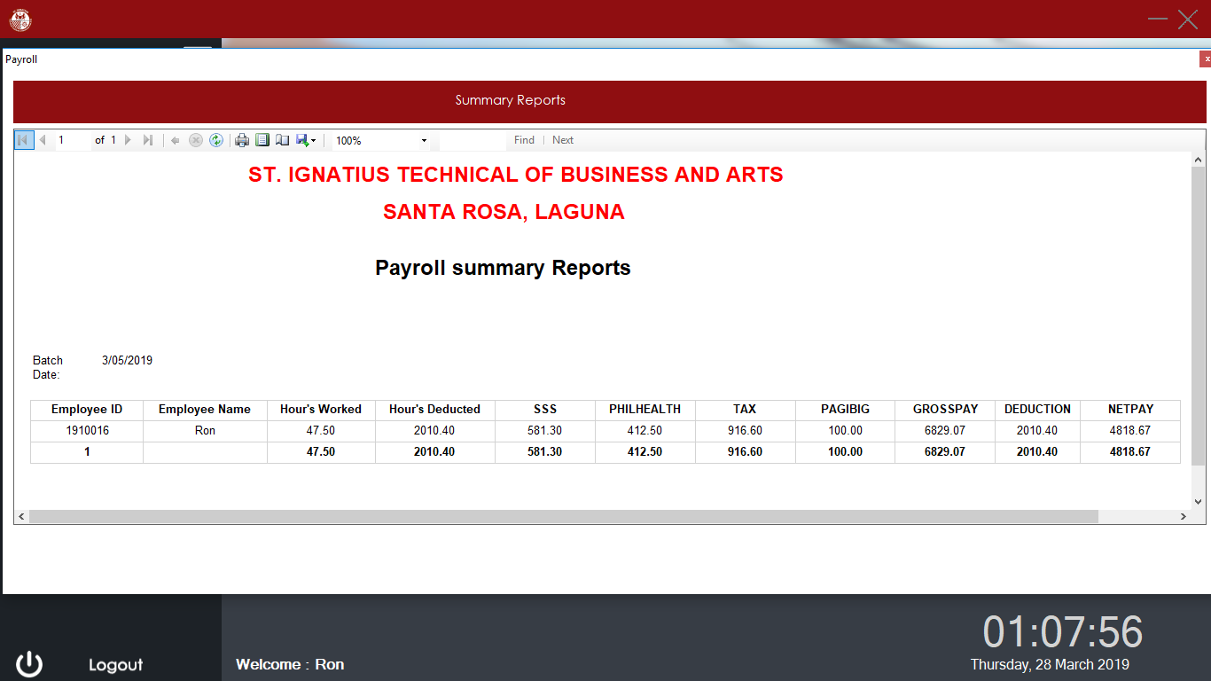

**Payroll Admin Reports**

This form shows your preview of summary and ready to print payroll summary reports for Admin.

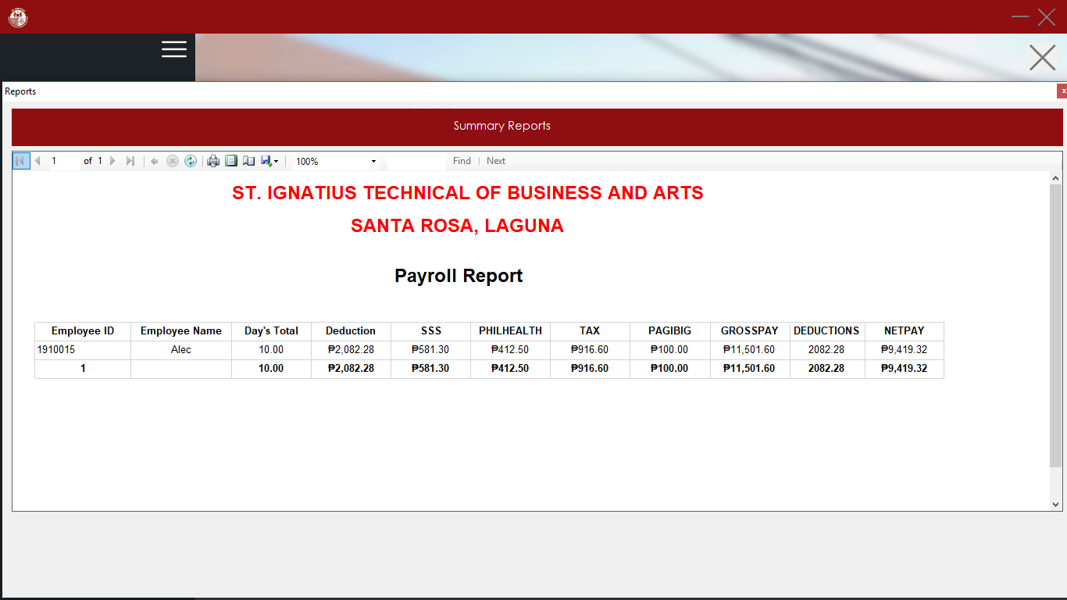

­­

**Pay slip Admin form**

This form shows a pays lip for your salaries, wages total number of days you work and all deduction to your gross pay and calculate your net pay this form is ready to print pay slip for admin, cashier, and regular employees only.

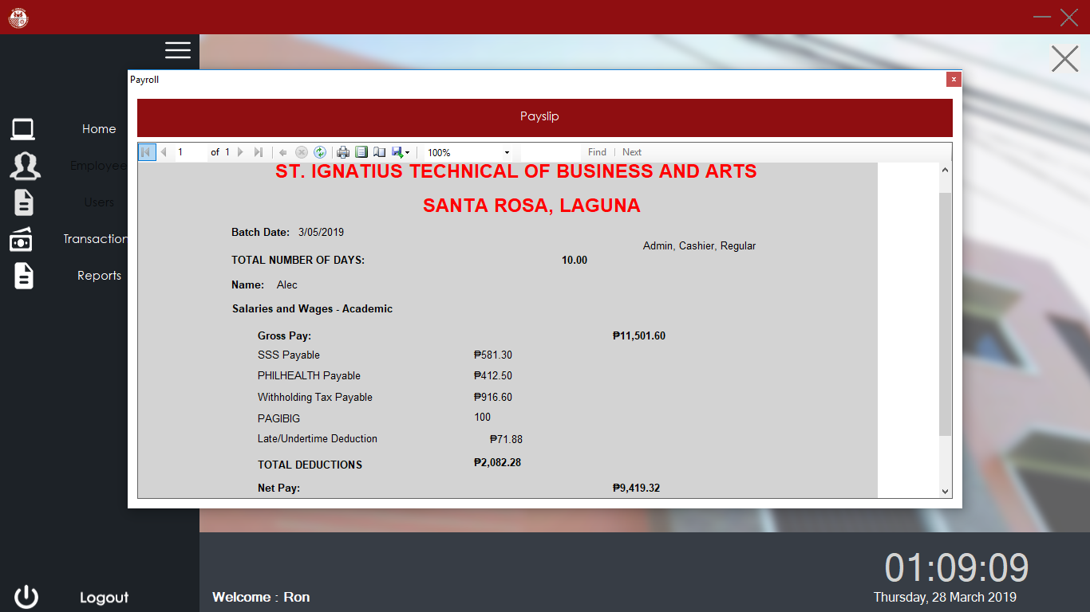

**Update leave form**

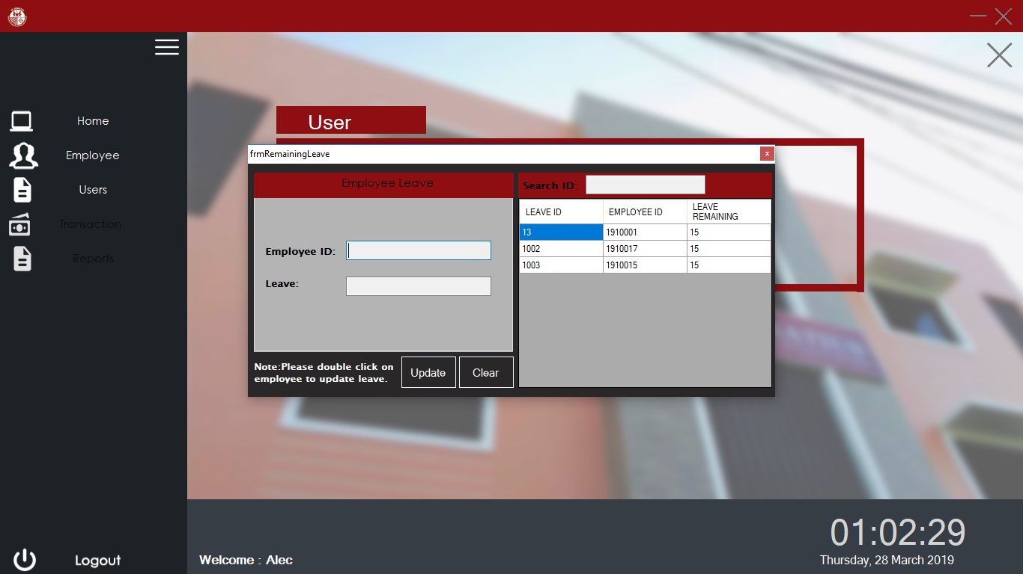This form shows your remaining leave for work. Only admin update this.

**User Login form**

The user must log in his or her employee ID number to have access in the system. If the user entered wrong password within three attempts, his or her account will be locked and the system will automatically be terminated. Only the admin is exempted on being locked out from his or her account.

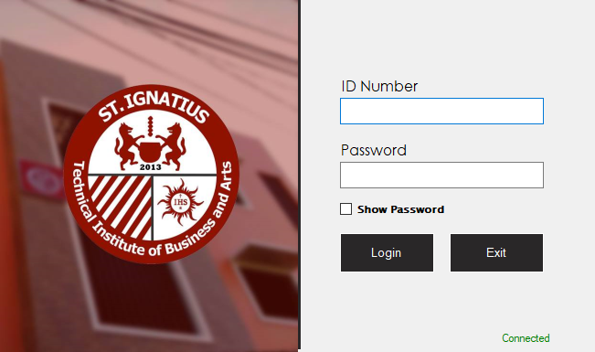

*Login Button*

*Username and Password*

*Text Field*

*v*

*Connection status*

**User Main Panel**

It is the main module of the system that has full access on the system. It shows the navigation button in left side and other function of the system.

*Navigation Bar*

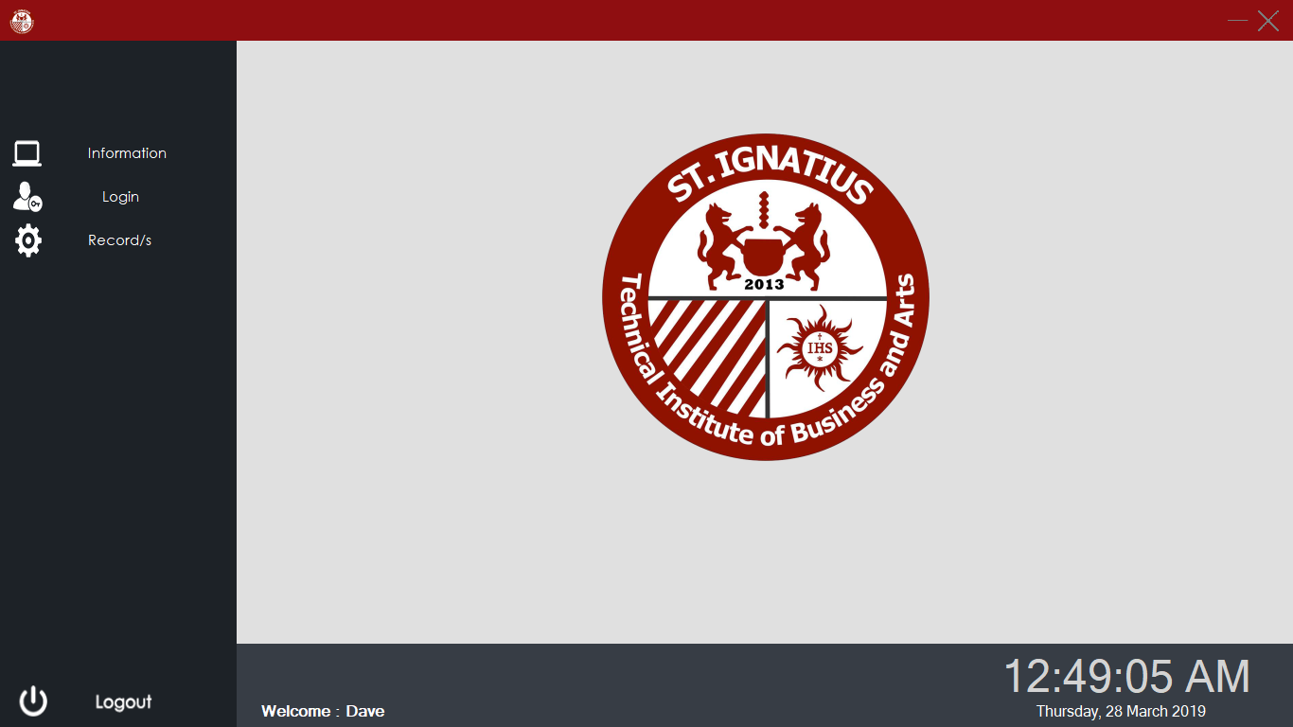

**Information form**

If you click Information button at the left side this will show you a basic information of a login user.

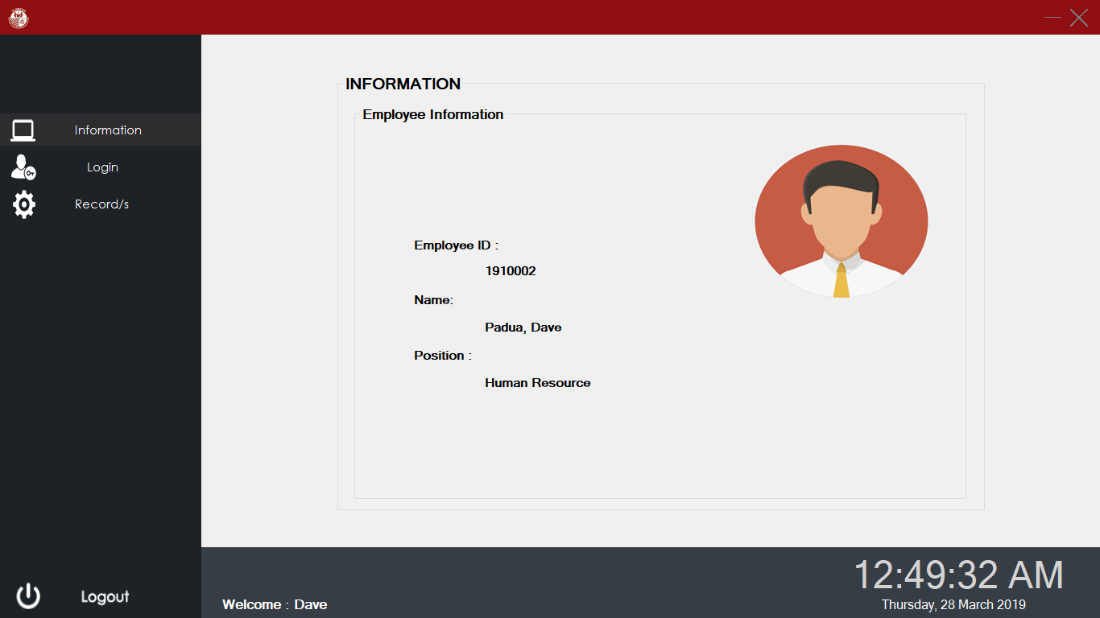

**Information form**

If you click Login button at the left side this will show you a time in and time out for a login user.

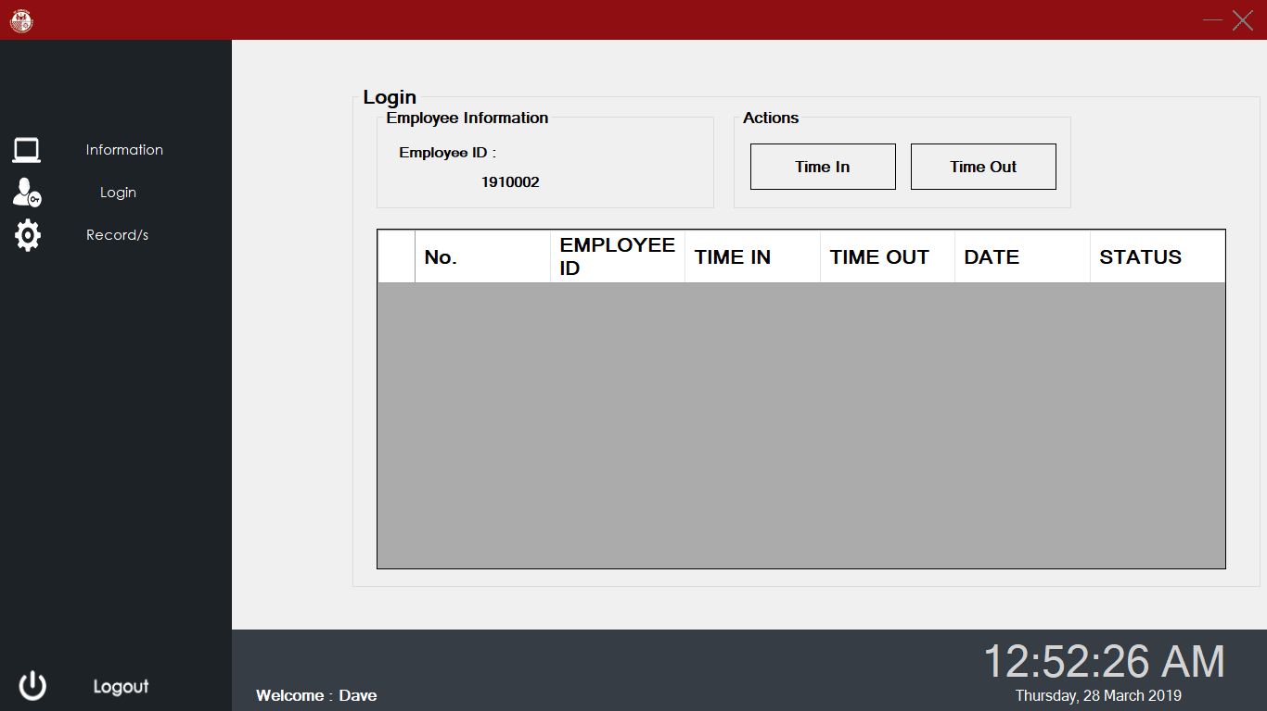

**Record form**

If you click record button at the left side this will show you a record of time and time out and working hours you enter to school and deduction to your late and benefits.

